**Steps for Eclipse Project Setup**

Prerequisite:

Download the following tools from the SVN from below URL Download jdk-jre, eclipse and tomcat

URL:

http://192.168.0.181:3690/svn/crestelmediation/projects/SM_REVAMP/tools/

1. File > New > Others > Project from SVN

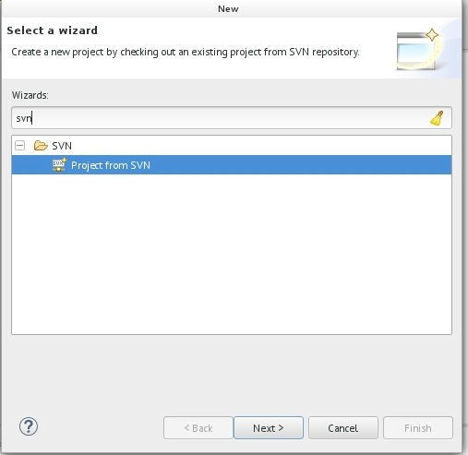

1. Enter Project SVN URL and Credentials

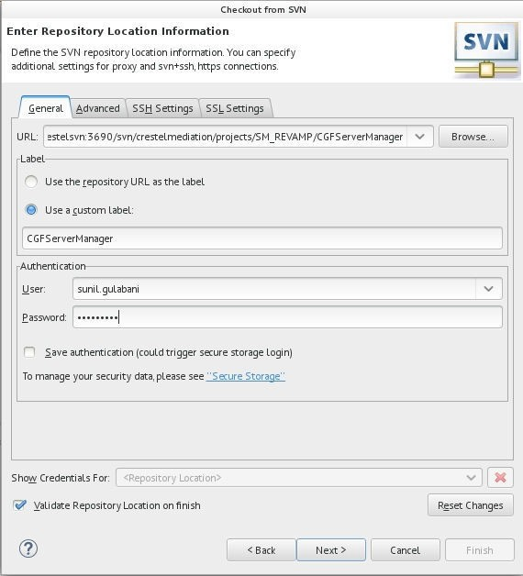

URl: http://192.168.0.181:3690/svn/crestelmediation/projects/SM_REVAMP/ServerManager/trunk

After adding details click Next

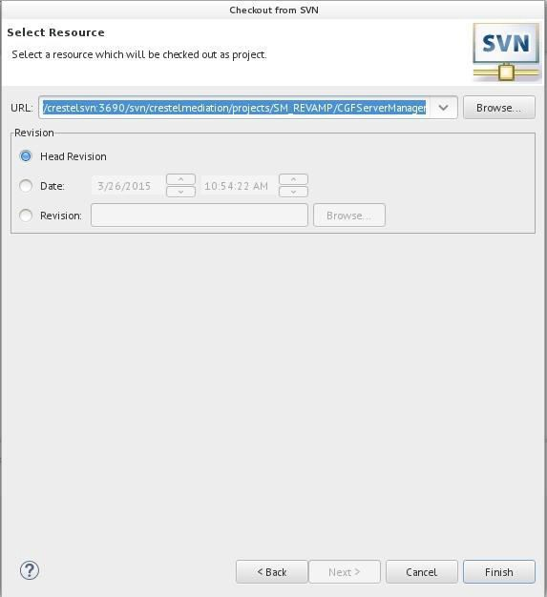

Click Finish

3. Checkout the Project

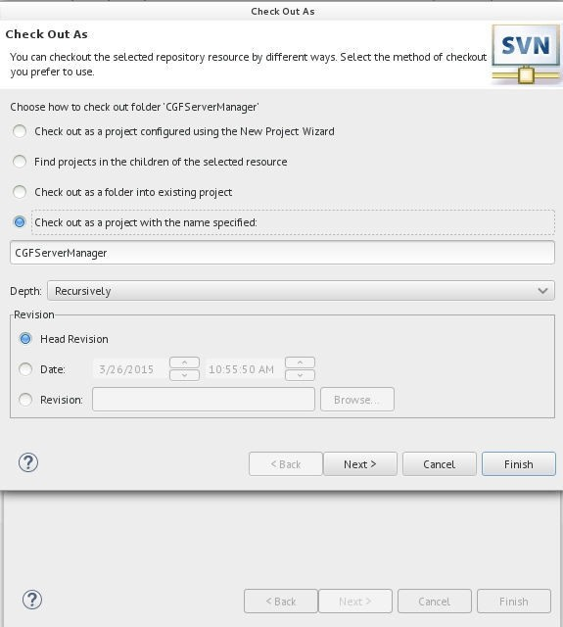

Click Next

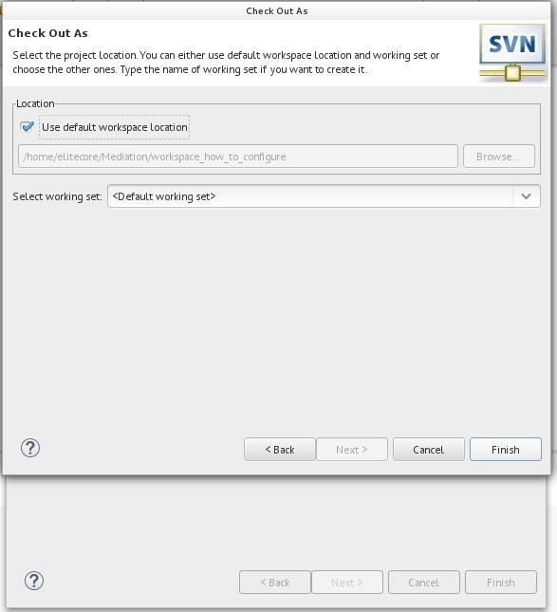

1. Project will be added to workspace

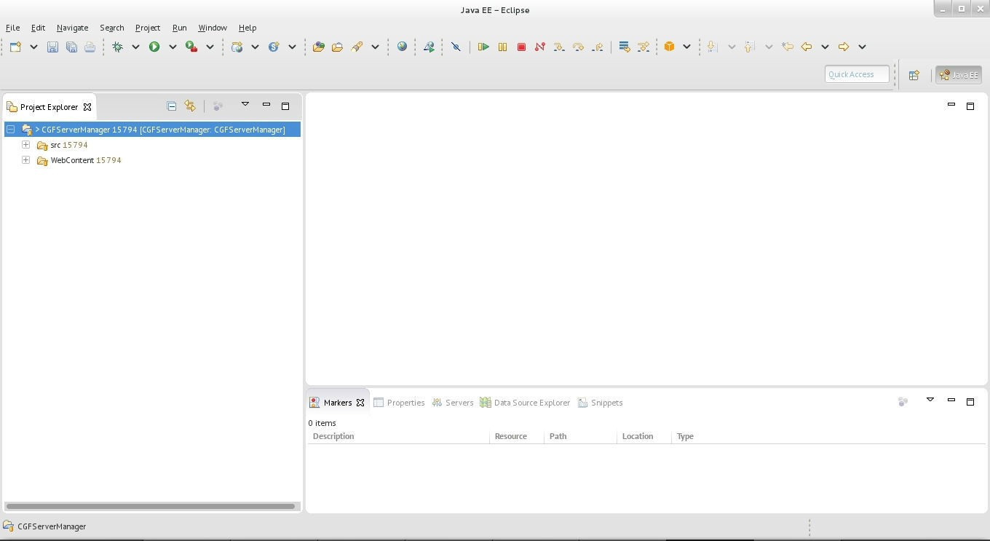

1. Right click on Project > Properties > Project Facets > Click on Covert to Facet Form...

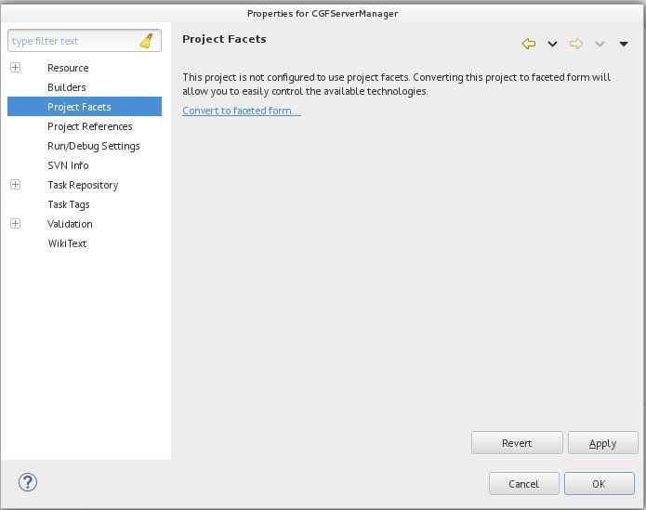

1. Select the Dynamic Web Project and Version as 2.5 or 3.0

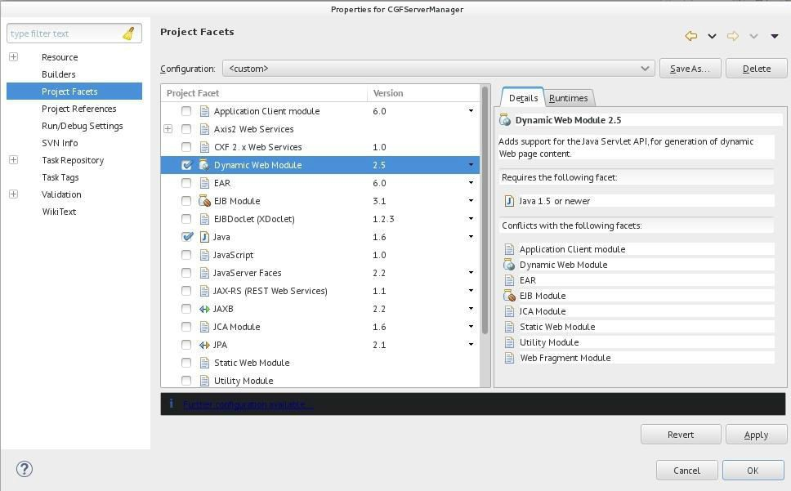

1. Click on Runtime Tab

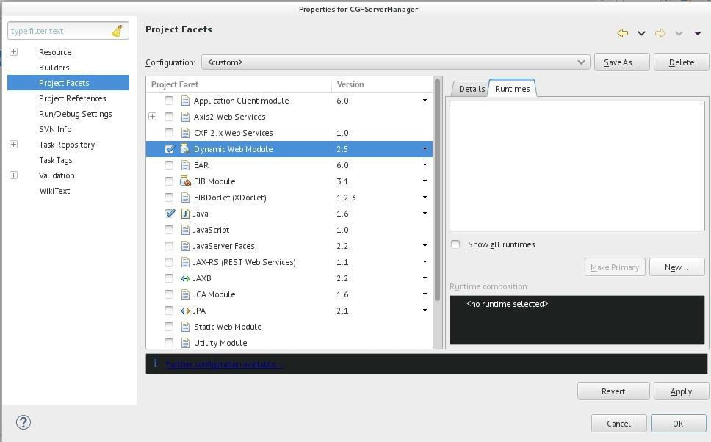

1. Add Tomcat Server 7 By clicking New in Runtime Tab

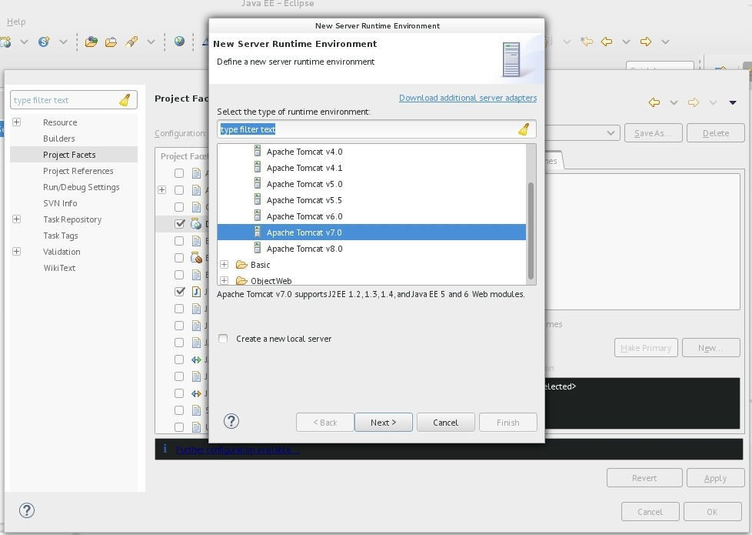

1. Add Tomcat Path

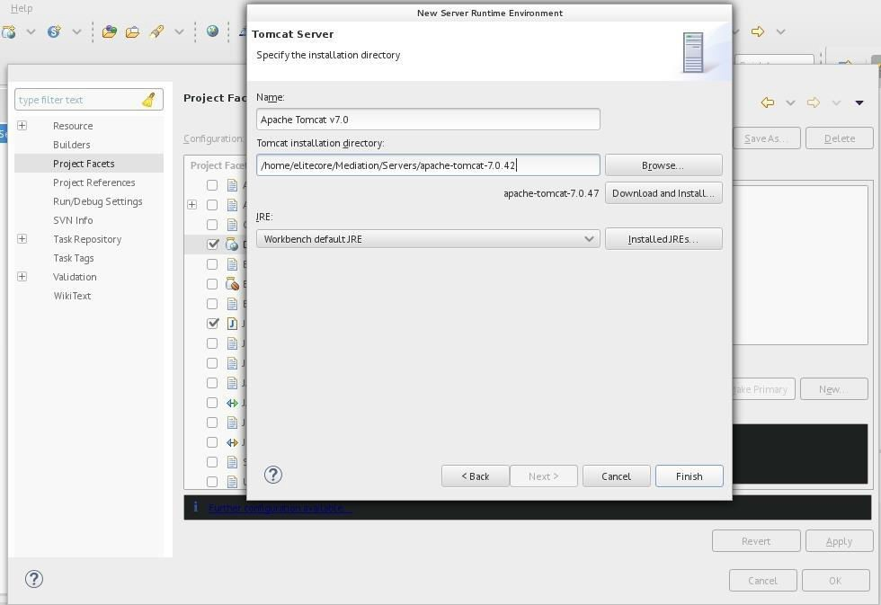

1. Select checkbox of Tomcat Server in Runtime Tab

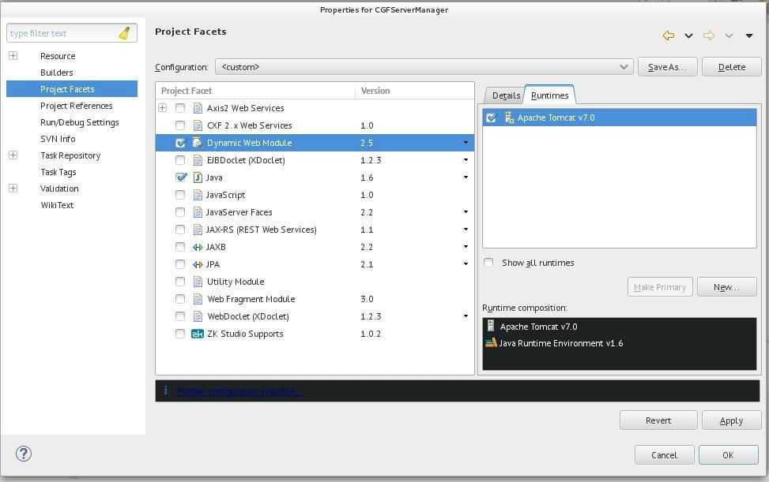

Click Apply and Then Click Ok.

1. In Server Tab View- double click on the Tomcat 7 Server and change the properties

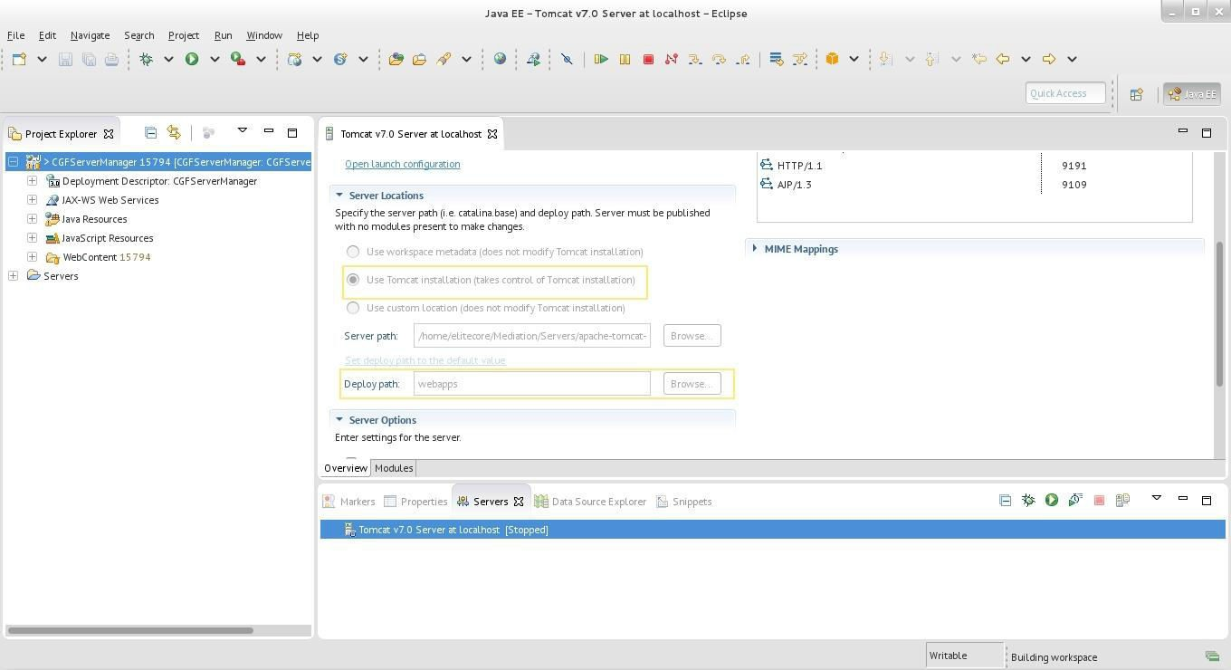

1. Change the deployment assembly properties

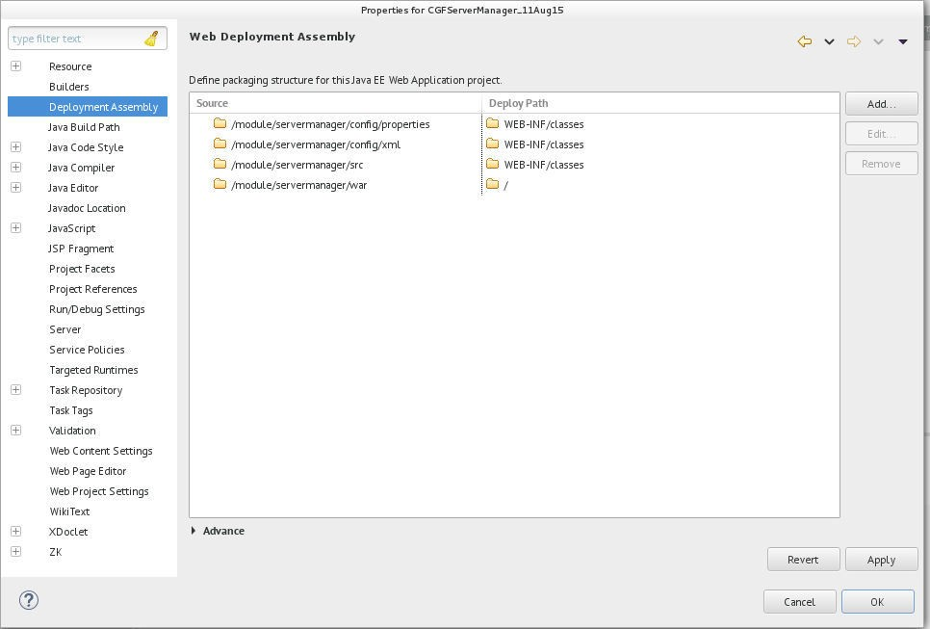

1. Change the source folder path

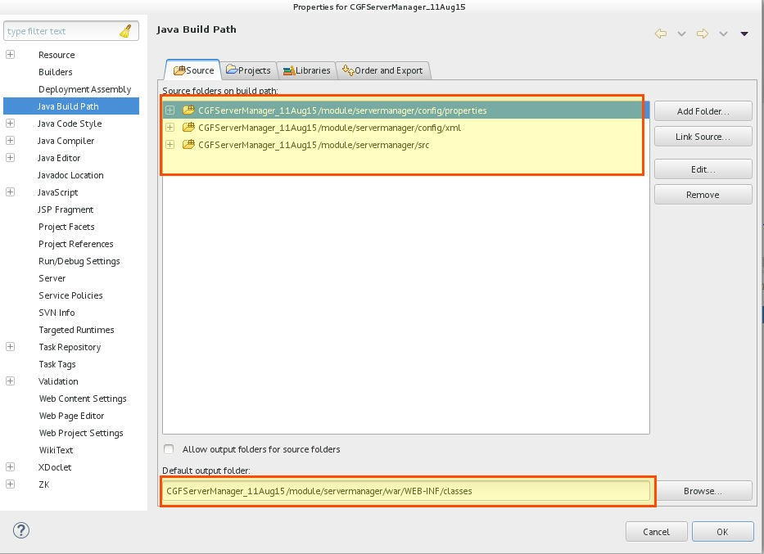

1. Add lib to Java Build Path & Check for JRE Library is bounded properly.

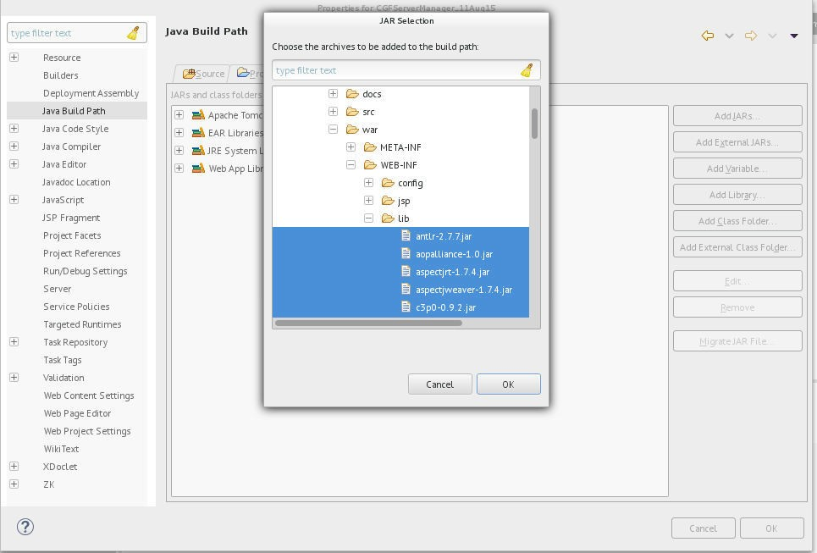

1. Add Context Entry in Tomcat config > server.xml

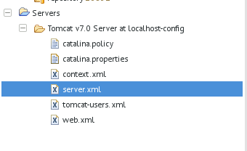

Add below context entry under host tag:

**<Context docBase=*"PATH_TO_WAR_FOLDER_IN_MODULE"* path=*"/sm"* reloadable=*"true"*/> Example:**

**<Context docBase=*"/home/elitecore/Mediation/workspace_how_to_configure_1/CGFServerManager_1/module/servermanager/w ar"* path=*"/sm"* reloadable=*"true"*/>**

Finally Project is configured

1. Now make suitable changes according to your database in liquibase_export.properties as mentioned in Database_agnostic_Liquibase_guideline.pdf file . Then your database will

be ready. Then make appropriate changes in jdbc.properties file.

1. Clean the Project and build it
2. Run the Server:

Go to Server Tab > Right Click Apache Tomcat Server > Start